**LAB ACTIVITY-6**

NAME:S.C.JAGADESH VARMA

REG.NO:1921100565

1.Develop a system using UML for Personal Loan Management System. The admin should add new customers and view the customer's records. The admin should check the defaulters. The customer can see his/her account detail and apply for a new loan by providing the required documents, and payslip. The admin should verify the document submitted and approve the loan after verifying the payback potential of the customer.

**AIM:** To draw an UML diagrams for Loan Management System using Umbrello software.

**USE CASE:**

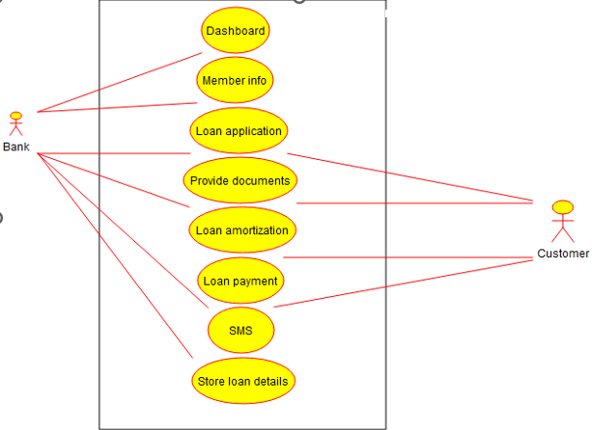

**CLASS DIAGRAM:**

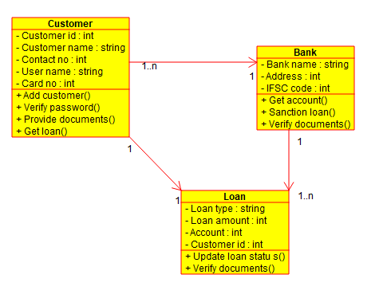

**ACTIVITY DIAGRAM:**

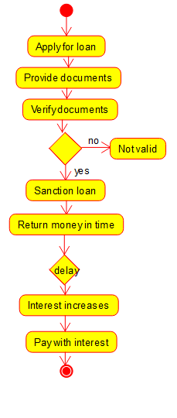

**STATE CHART DIAGRAM:**

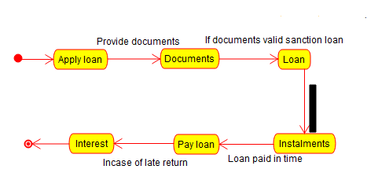

**COMPONENT DIAGRAM:**

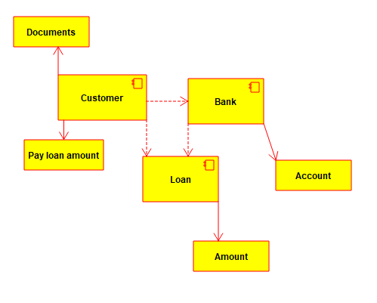

**DEPLOYMENT DIAGRAM:**

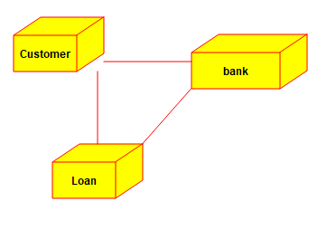

**SEQUENCE DIAGRAM:**

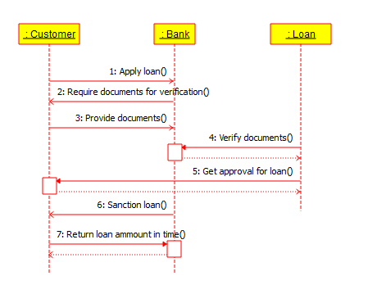

**COMMUNICATION DIAGRAM:**

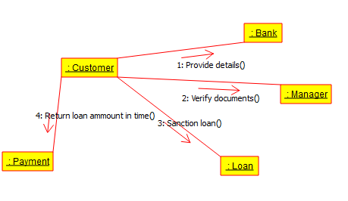

**ENTITY RELATIONSHIP DIAGRAM**

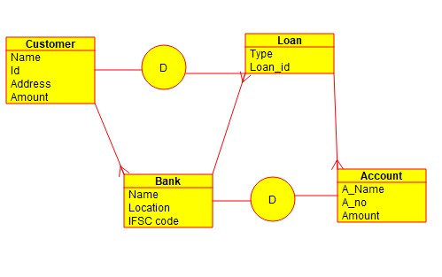

**RESULT:** Thus an UML diagrams for Loan Management System has been drawn successfully by using Umbrello software.